

**DATA DRIVEN INSIGHTS INTO TRADITIONAL FINANCING VS**

**ALTERNATIVE FINANCING FOR STARTUP ECOSYSTEM**

PROJECT REPORT

SUBMITTED BY

ENIYAVAN R S

RRN: 230292601074

In partial fulfilment for the award of the degree of

**MASTER OF BUSINESS ADMINISTRATION**

Under the Guidance of

DR. RITU GANGIL

ASSISTANT PROFESSOR

CRESCENT SCHOOL OF BUSINESS

**B S ABDUR RAHMAN CRESCENT INSTITUTE OF SCIENCE AND TECHNOLOGY**

MAY-2025

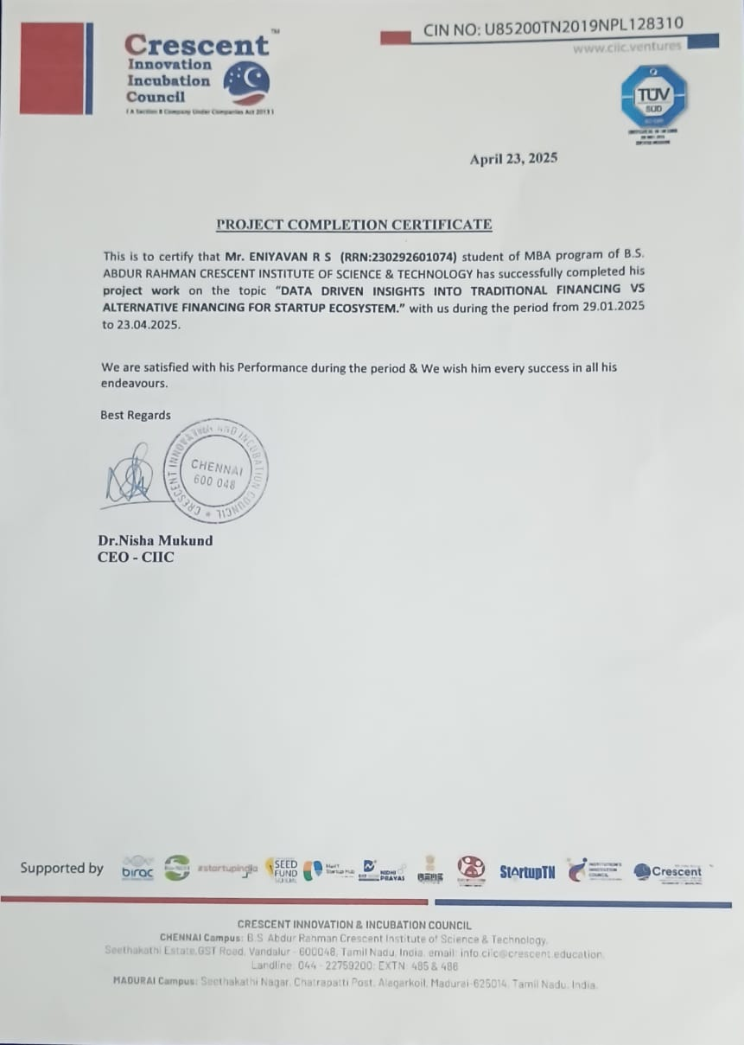

**ACKNOWLEDGEMENT**

First and foremost, we would like to begin with thanking The Almighty, for whom We owe what We have achieved so far.

We would like to express my heartfelt gratitude towards the people whom We respect for their assistance, support, and encouragement in so many ways during my study.

I would wish to express my sincere gratitude to **DR. SRINIVASAN,** Dean, Crescent School of Business and **DR. S.K.G. GANESH**, Head of the Department of Management Studies, **B.S. ABDUR RAHMAN CRESCENT INSTITUTE OF SCIENCE & TECHNOLOGY** for his encouragement and wishes.

I express my deepest gratitude to my supervisor **Dr. Ritu gangil** for the useful comments, remarks, motivation and engagement throughout the internship process. I extent my gratitude to **CIIC (Crescent Innovation and Incubation Council)** for the opportunity to work with the company as an intern. There I have learnt more about the process of the company in detail by exploring all department in the company and I liked to thank my external supervisor **Ms. Yasmeen and Prakash’s sir** for the support and assistant for the project work.

The success and final outcome of this project required a lot of guidance and assistance from many people, and I am extremely privileged to have got these all along the completion of my thesis. All that we have done is only possible by such supervision.

We also thank my supportive family for their patience, compassion, and guidance. We would not able to complete without their help and support.

Moreover, we will never forget to thank my true friends who have been there for helping me along the way till this work was finally done.

To those people, we dedicate this thesis with acknowledgement and pride.

|  |  |  |
| --- | --- | --- |
|  | **TABLE OF CONTENTS** |  |
| **CHAPTER** | **TITLE** | **PAGE NO** |
| **CHAPTER I** | **INTRODUCTION** |  |
| **1.1** | Industry /company profile | 1 |
| **1.2** | Review of Literature | 13 |
| **1.3** | Research Background & Research gap | 16 |
| **1.4** | Identified research problem | 18 |
| **1.5** | Objectives of the study | 19 |
| **CHAPTER II** | **METHODOLOGY** |  |
| **2.1** | Research Project design | 20 |
| **2.2** | Sampling &Data collection method | 21 |
| **2.3** | Tools used for Analysis | 21 |
| **CHAPTER III** | **DATA ANALYSIS AND INTERPRETATION** |  |
| **3.1** | Data, Analysis and Inferences | 22 |
| **3.2** | Chi Square | 32 |
| **3.3** | ANOVA | 34 |
| **3.4** | Independent T-test | 38 |
| **3.5** | Correlation | 40 |
| **3.6** | Regression | 42 |
| **CHAPTER IV** | **SUMMARY & SUGGESTION** |  |
| **4.1** | Summary of Findings | 43 |
| **4.2** | Suggestions/Recommendations | 46 |
| **4.3** | Limitations | 47 |
| **4.4** | Directions for Future Research | 48 |
| **CHAPTER V** | **ANNEXURE** |  |
| **5.1** | Questionnaire/Interview Schedule | 56 |
| **5.2** | Bibliography References | 60 |

**LIST OF TABLES**

|  |  |  |
| --- | --- | --- |
| **Table No** | **List of Table** | **Page No** |
| **1.1** | Unicorn Club | 2 |
| **1.2** | Schemes | 3 |
| **1.3** | Scheme Under Education | 5 |
| **1.4** | Founding Support by CIIC | 12 |
| **3.1** | Descriptive Statistics | 23 |
| **3.2** | Generation | 25 |
| **3.3** | Education | 26 |
| **3.4** | Startup Stage | 27 |
| **3.5** | Source of Finance | 28 |
| **3.6** | Startup been Operates | 29 |
| **3.7** | Types of Traditional Financing | 30 |
| **3.8** | Reliability Test | 32 |
| **3.9** | Chi-Square Test | 33 |
| **3.10** | Chi-Square Test 2 | 34 |
| **3.11** | ANOVA Analysis | 35 |
| **3.12** | Post HOC | 35 |
| **3.13** | ANOVA Analysis 2 | 36 |
| **3.14** | Independent T-test | 38 |
| **3.15** | Independent T-test 2 | 39 |
| **3.16** | Correlation | 40 |
| **3.17** | Regression | 42 |

|  |  |  |
| --- | --- | --- |
| **Figure No** | **List of Figures** | **Page No** |
| **1.1** | Top sectors list | 4 |
| **3.1** | Generation | 25 |
| **3.2** | Education | 26 |
| **3.3** | Startup Stage | 27 |
| **3.4** | Types of Financing | 28 |
| **3.5** | Startups Operates | 28 |
| **3.6** | Traditional Financing | 29 |
| **3.7** | ANOVA | 37 |
| **3.8** | Correlation | 40 |

**LIST OF FIGURES**

**ABSTRACT**

In the rapidly evolving landscape of startups, access to appropriate financing is a critical factor for success. This project provides a comprehensive data-driven analysis of traditional and alternative financing options available to startups, emphasizing the differences in awareness, flexibility, control, risk, stability, and associated challenges. By integrating quantitative methods, including chi-square and ANOVA tests, this study uncovers key insights into the impact of these funding approaches. The analysis reveals that startups with higher awareness and knowledge about diverse financing sources tend to make more strategic financial decisions, enhancing their growth potential. Traditional financing options, while offering stability, often come with rigid requirements, whereas alternative financing provides greater flexibility but can involve higher risk and complexity. The chi-square test results indicated a significant association between financing choice and startup maturity, while the ANOVA analysis highlighted distinct variations in perceived financial stability and control across different funding methods. These findings offer critical guidance for entrepreneurs seeking the most suitable financing strategies and provide a foundation for future research aimed at bridging the gaps in startup funding ecosystems.

**CHAPTER 1**

**INTRODUCTION**

**1.1 INDIAN STARTUP ECOSYSTEM / COMPANY PROFILE**

In India, the idea of the startup ecosystem is becoming more and more important and fasting scenario. This ecosystem includes the full progress from ideation to the development of novel and commercially viable product or services that can endure in the market for a long time and ultimately result in the establishment of well-known businesses. A network of people, institutions, and organisations that work together to support the establishment, expansion, and success of startup endeavours is known as a startup ecosystem. Numerous important players support this platform and help turn startups into unicorns, decacorns, gazelles, and cheetahs. These participants, who collaborate closely to foster innovation and business development, are entrepreneurs, investors, incubators, accelerators, mentors, government organisations, and educational institutions. The combined efforts backing of these Stakeholders assists entrepreneurs in turning their concepts into viable business plans.

In India, the startup environment is a more changing and significant term. Its systems process focusses on ideation, creating innovative products and services that are long-term commercially viable, and building a reputable business. A startup ecosystem is a network of people, organisations, and institutions that work together to provide a strong foundation as a startup guide to upcoming innovators for the establishment, expansion, and prosperity of new businesses. Additionally, there were additional players behind this platform who could turn a startup into a unicorn, cheetah, gazelle, or decacorn. In order to foster innovation and business development, they may be entrepreneurs, investors, incubators, accelerators, mentors, government organisations, academic institutions, etc.

Every member's assistance aids a startup in turning his concept into a business plan. The largest ecosystem for startups is found in India, where they can access tangible, supportive infrastructure. From 2018 to 2024, the Indian startup ecosystem grew at an exponential rate, averaging between 12% and 15% annually, especially in 2018. DPIIT has recognised 50,000 startup companies, of which 8,000 to 9300 are technology-oriented innovation startups. In 2019, 1300 tech startups were born every day, making India the third-largest startup ecosystem in the world. India is ranked second for quality innovation, which addresses actual problems that could enhance the name of the country recognize globally and has a significant impact on transformation. India is now home to 118 distinct startups valued at USD 354 billion. Forty-five of these unicorns were born in 2021, and twenty-two in 2022. There were two unicorns in 2023, and this year is marked as a slow year for startup growth. In 2024, six unicorns were born. By this quantitative representation, we can firmly say that india is more towards an innovation development by backing the potential startup ecosystem.

India, a developing nation, produced more unicorns than developed nations like the UK, which has the second-largest startup ecosystem, with 118. Because of its larger population, vast marketplace, and self-assured citizens, India is able to produce more startups. Governments decide to educate students and all Indian citizens about innovation, helping them understand how it makes our country stand out and can help us become a developed nation. With the support of more startup companies, India's GDP can grow and more job opportunities can be created for many Indians. which results in the creation of per capita income, which raises people's standard of living. In this corporate company are in hand-to-hand support to government by CSR activities where the companies can support this startup ecosystem by giving them financing support from their CSR activity Budget for this more corporate are willing to take part in this because of it will be a future return benefits which influence this companies to take part in startup ecosystem.

As of 2024, India is home to 67 unicorns, 46 gazelles, 106 cheetahs, and five decacorns. These big player are valued at more than $1 billion. It covers a wide range of industries, such as fintech, SaaS, e-commerce, EdTech, and more. Gazelles are high-growth startups that were founded after 2000 and have the potential to become unicorns within the next three years; Cheetahs are startups that were founded after 2000 and are expected to become unicorns within the next five years; and Decacorns are startups that are valued at more than $10 billion in India. There are five startups in Decacorn.

Recently joined Indian Unicorn Club

|  |  |  |
| --- | --- | --- |
| **Name** | **Sector** | **Valuation** |
| Netradyne startup | AI, SaaS | $1.34 Bn and above |
| Juspay startup | Fintech | Over $1 Bn and above |
| Ather Energy startup | Electric vehicle (EV) | $1.3 Bn and above |

*Table 1.1*

**GOVERNMENT INITIATIVES**

Besides the many awareness program’s government made more initiatives to support the startups from the ideation stage to the Scaling stage. Their initiative includes funding support, helps in market connecting and also organising startup programs that attracts more young minds into the startup ecosystem, the government has planned this as a sector-specific approach where each ministry will support that specific sector of innovative startup ideas approximately around 16 ministries collectively contribute to creating a robust startup ecosystem in India. Which will more attractive speech in budget has been made to attract more startups and innovative ideas to be boldly taken over their idea to next stage without any hesitation. Where government plays a crucial role as a promotor of startups without such support and initiative this kind of success won’t be achieved and these unicorns are not shown up and more individual innovator don’t come up to express their ideas boldy with a second thought that whether this idea gets any funding support from venture capitalist and angel investors. So, their supportive initiatives Like,

“Just thing of an Idea, Government were ready to fund for your process of transformation”

|  |  |  |
| --- | --- | --- |
| **Schemes** | **Ministries** | **Sector** |
| Startup India Seed Fund Scheme | Commerce and Industry | Sector Agnostic |
| SAMRIDH | Electronics and Information Technology (MeitY) | Technology startups focusing on product innovation and development. |
| NIDHI PRAYAS | Science and Technology (DST) | Technology Driven Startups. |
| Atal innovation Mission (AIM) | NITI Aayog | Agriculture, health, education, energy, water etc, |
| TIDE 2.0 | MeitY | Information and communication Technology. |
| iDEX | Defence | Defence, aerospace. |

*Table 1.2*

Likewise, there are several schemes available for startups through which the government provides funding support for innovative ideas, especially those aimed at developing prototypes and product-related solutions. Once a startup crosses the early-stage phase, the next critical and challenging step is scaling the business. This stage is often risky and difficult to sustain due to the highly competitive environment. To address this uncertainty, the government has launched various acceleration programs designed to support startups during this transitional period from scaling to marketability between early growth and market scalability. These programs offer access to mentorship, funding, business development support, and investor networks that help 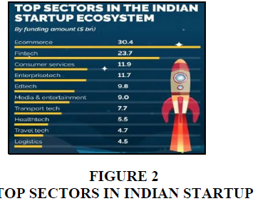startups prepare for long-term market success.

*Figure 1.1*

**INCUBATION PROGRAM**

One of the most impactful government initiatives has been the establishment of incubation centres within colleges, which has become a requirement for institutions seeking AICTE (All India Council for Technical Education) certification to acquire this certificate college should setup Incubation program in their college to enforce student to involve in more practical way of learning, while this enforcement varies, many such college based incubators have already supported 50+ startups. The primary aim of this initiative is to attract the youth of India into the startup ecosystem from an early stage. The term “incubation” is used because these centres nurture startups like infants where infants are kept in incubator to provide support for their living and make sure whether the infant is able to sustain to the ecosystem likewise for startups which providing them with essential resources, guidance, and protection until they are ready to enter and compete in the real business world. By embedding these incubation centres in educational institutions, the government ensures that innovation is not just encouraged, but actively supported at the grassroots level, helping to build a strong and self-sustaining startup culture across the country. For this introduction of incubation program government have anticipated more ideas will comes from this program so they thought of introducing particular Schemes under Ministry of Education (MoE)

|  |  |
| --- | --- |
| **Schemes** | **Support** |
| Institution Innovation Council (IIC) | Focus on offering the ecosystem for innovation for students and encourage them in ideation, pre-incubation. |
| Smart India Hackathon (SIH) | To promote product innovation and problem-solving mind set in youth minds |
| YUKTI | Identify and support innovative solutions by students |

*Table 1.3*

Which helps to generate more innovative ideas from new comer minds which will be entirely different from an industry person these schemes are not limited to student’s related schemes are there where a staff can express their idea and get funding from government.

“As a student you don’t compromise your potential to think of new and out of book thoughts”

**INVESTORS**

In addition to incubators, a growing number of investors are becoming interested in the startup ecosystem because they see it as a promising avenue for future investment. These investors offer market access to creative ideas in the same industry in addition to financial support. This strategy greatly increases innovators’ and startups’ accessibility and growth potential, particularly when their concepts have a significant impact and address pressing societal issues.   
Government grants frequently concentrate on concepts that support the goals of national development. Because of this, not all creative ideas are supported by public funds. In these situations, private investors are essential because they step in to help startups whose ideas might not be acknowledged or approved by government programs but still have a great chance of success and impact.

As a result, investors are a vital part of the startup ecosystem, providing both capital and strategic support to help bridge the gap between innovation and execution. Even government-supported startups can benefit from private funding opportunities to scale and expand further. Angel investors, venture capitalists, and individual investors are the three main categories of investors, and each group has a unique role to play in fostering early-stage ventures and driving innovation within the economy. Additionally, the involvement of investors can accelerate the time to market, attract additional funding, and enhance credibility. As the startup ecosystem develops, the synergy between public support and private investment is becoming more and more important for promoting sustainable innovation.

“Time is precious, this is a time to innovate investors are there to support you”

**MENTORS**

Mentors are essential in the startup ecosystem because they help shape the paths of aspiring business owners. They are usually seasoned professionals, prosperous business owners, or subject-matter specialists who offer their wisdom, perspectives, and first-hand experiences to mentor fledgling companies. A mentor serves as a trusted advisor who assists founders in honing their concepts, creating a viable business plan, and avoiding typical mistakes that arise when launching a new company. Individual who doesn’t have a proper mapping for their ideas, and who are all suck in particular point where mentors assist startups in their break-out point. They offer insightful advice on growth strategies, product development, market entry, and strategic planning. In addition to offering guidance, mentors help startups connect with partners, investors, and other industry participants, opening doors to valuable networks. Their assistance frequently extends beyond the workplace. They serve as a sounding board in trying times and provide inspiration and support. With their practical knowledge and expertise.

“Teachers who taught for journey of innovation”

**CO-WORKING SPACE**

The co-working space concept was developed to support startups in particular because it is crucial for entrepreneurs because, in their early stages, it is hard to find affordable workspace to operate their business due to budgetary constraints, credit risk, etc. These areas offer a cooperative setting where new businesses can connect, exchange resources, and develop together. By this interaction startups can you an brainstorming session between each startups which helps startups to break out the prolonged problem area with help of co- working space. When different minds come together, it creates a new way of thinking. Some incubation centres, accelerators, and other organisations provide these co-working spaces. Here, they hold workshops and events that encourage creativity and offer chances for cooperation.

“Co- work means Co-ordinate, Co-operate and to make proper communication between the space users”

**NETWORKING EVENTS**

By encouraging relationships, cooperation, and educational opportunities between entrepreneurs, investors, industry professionals, and support groups, networking events are essential to sustaining the startup ecosystem. Pitch contests, startup summits, hackathons, demo days, workshops, and panel discussions are some examples of these events. Startups can validate ideas, get feedback, and comprehend market expectations by attending these events, which expose them to possible partners and investors. They also give founders a forum to discuss their experiences, difficulties, and inventions, which can enlighten and motivate other members of the ecosystem. Additionally, these meetings promote cross-sectoral idea sharing, which frequently results in surprising alliances or changes to business plans. Incubators like T-Hub or NSRCEL, as well as organisations like TiE and NASSCOM, frequently host events that bring together thought leaders and developing startups, fostering a cooperative atmosphere that encourages the expansion of entrepreneurship. Regularly attending networking events is frequently a first step towards visibility and long-term growth in the fast-paced, cutthroat startup world.

**Reason behind choosing this topic:**

**“Data- Driven insights into Traditional Financing Vs Alternative Financing for startup ecosystem”**

Growth in startup ecosystem for India is in moving state. For this trend to go upward, the funding source is very important that the reason this financing has been improved over time which leads to introduction of alternative financing then they formed source of financing by combining both traditional and alternative financing as a single head source for financing to startups. Which is the main factor in the success and growth of an idea into established product with funding nothing can be achieved, even though support and guidance can be obtained with some effort of building strong network of connection, but this funding cannot be achieved, this is one of the reasons but with paraphrasing this name which is not familiar with many of the people like other initiative. So many were unaware about this type of funding is available for startup and how this type of funding firmly helps the startups to grow in fast paced business world with this funds, and which type of financing they use most and the reason behind choosing it whether they use valuation methods, or experience in similar field of areas which helps them in acquiring this type of financing very easily or they have knowledge and awareness with this type of financing already is their to support the startup ecosystem and the way they approach this sources increasingly. Where I have done internship in CIIC for 3 months in that duration I have noted that more startups are from technology related areas were improving fields like AI, Machine learning, quantum computing, cloud computing, IOT technology innovation. From this I recalled the technology which was used before 1000 BC to build the great temple in Tanjavur and I realized that Indian is the place for creativity and Indians are makers rather than builders. And I have also noted that major of the idea generators and innovators comes to incubation because they mostly don’t about such schemes and their eligibility criteria to fill up these forms, from this I had a confusion about those innovators those who approach to this incubation were don’t know about this scheme then for other peoples with their idea only don’t know where to go and approach this been a challenging scenario for incubators to approach all and explain this. So, I taught of go with this topic collect the awareness levels from startups because if they know about this funding source which helps them to convers their understanding with other people’s it vans spread through all which helps in familiarizing this concept.

### INTRODUCTION

“Crescent Innovation and Incubation Council (CIIC): A Stepping Stone for Startup Success”

A dynamic platform that fosters innovation, develops entrepreneurial talent, and speeds up the expansion of startups in India, it was founded in 2019 as a Section 8 non-profit organisation. With a focus on cutting-edge fields like life sciences, industry 4.0, smart and clean industries, and defence technologies, CIIC was founded with the goal of assisting early-stage and ideation entrepreneurs. After assisting hundreds of startups at different phases of development, from ideation to acceleration, CIIC has developed into a reliable ecosystem enabler in just over five years. Many of these startups have since achieved noteworthy success and recognition. The “5M” model of support—Money, Material, Mentor, Market Connect, and More—is the foundation of CIIC’s operations. Services. The most important requirements of start-up companies are met by this all-inclusive framework. No startup is left behind because of a lack of resources or guidance thanks to CIIC, which offers seed funding, access to lab facilities and prototyping tools, market connections, industry experts, mentors, and legal, technical, and business advisory services.

As an incubator, CIIC’s main responsibility is to support startups during their most precarious stages. Early-stage funding, operational infrastructure, and strategic direction are challenges for many aspiring business owners. In addition to providing co-working spaces and essential infrastructure, CIIC bridges this gap by securing government funding. Serving as a liaison between startups and federal or state government programs, CIIC assists startups in navigating the frequently intricate eligibility requirements and documentation procedures needed to obtain public grants and funding.

At the moment, CIIC is actively overseeing eight significant government programs, all of which are meant to encourage entrepreneurship and innovation. Based on the startups’ successful completion of predetermined milestones, these schemes release funds in tranches. CIIC is essential to tracking developments, guaranteeing adherence, and enabling the efficient release of these monies. More significantly, CIIC encourages accountability and long-term development among its ncubates in addition to offering financial support.

In addition to incubation, CIIC has a strong commitment to fostering an innovative mindset, particularly in students and early professionals. To encourage entrepreneurial thinking and expose aspiring business owners to real-world business challenges, regular awareness campaigns, workshops, boot camps, hackathons, and networking events are planned. According to CIIC, innovation should be ingrained in society as a whole, starting in educational institutions, rather than being limited to startups. In order to achieve this, they actively work with academic institutions and research centres to find innovative ideas and mentor student entrepreneurs as they pursue their entrepreneurial goals.

Currently in the acceleration stage, some of the most successful companies CIIC has backed are expanding quickly into both domestic and foreign markets. Their achievements serve as evidence of CIIC’s dedication and influence. Through technological advancements in manufacturing, healthcare, sustainability, and defence, these startups have not only produced job opportunities but also aided in the development of the country.

To put it simply, CIIC is more than just an incubator; it serves as a trail room for innovators, a catalyst for innovation, and a crucial tenet in the development of an independent, startup-driven economy. CIIC continues to influence the direction of entrepreneurship in India with its well-organised support system, strategic mentoring, and strong network of partners.

**Vision**

* To become a university-based Technology Based Incubator of Excellence with national & international allusion parameters
* To reform entrepreneurial student aspirants into start-up establishment
* To support & render start-up into a profitable entity.
* To transform innovation into scalable business models with high productive impact and also encouraging interdisciplinary advancement.
* To create impact for economic development and community wealth

**Mission**

* To recognize and nurture students, faculty members and alumni into early stage startups.
* To create and promote collaborative networks through partnerships between academia, industry and government.
* To increase and advance the in-house operational skills for leveraging entrepreneurial expertise and resource network.
* To identify & nurture top-notch entrepreneurs in Life Sciences, Industry 4.0, Smart and Clean Mobility through expert mentoring and also to foster lean startups to sustainable companies.

**Achievement so far for CIIC**

CIIC has successfully created 128 startups till date and also,

Filled 122 Patents for unique ideas primarily to safeguards and holds an ownership for those ideas

CIIC have successfully created 1341 Jobs opportunities

CIIC has been selected as one of the top 12 incubators in Chennai by Startup TN

CIIC obtained 5 STAR Ranking from IIC (Institution’s Innovation Cell) by ministry of education.

CIIC have granted many governments scheme under 8 ministries which supports in startups

**Function as a networking opportunity for investors and collaboration**

By supplying financial support from its own funds, CIIC serves as both an incubator and an investor. Strategic Memorandums of Understanding (MoUs) with financial institutions, such as banks and institutions like the United Economic Forum (UEF), enable this. Startups can obtain early-stage funding through these partnerships, particularly in situations where government grants or traditional venture capital are not readily available. Along with financial support, CIIC provides reasonably priced co-working spaces, both online and in-person, to help startups lower their early operating expenses. Without having to worry about expensive rentals, this infrastructure enables them to concentrate more on product development and innovation.

Additionally, by fostering communication between incubated startups, CIIC fosters a collaborative ecosystem. Founders can discuss problems, come up with solutions, and create valuable networks in this community-driven setting. The close proximity of CIIC to academic institutions is one of its distinctive features, as it enables startup founders to interact directly with students and young innovators. These exchanges frequently produce novel, unconventional ideas that assist founders in finding weaknesses in their models, investigating different strategies, and getting objective input from a younger viewpoint. CIIC plays a vital role in transforming early-stage innovations into scalable and socially relevant businesses by fostering such a vibrant and inclusive environment.

**Founding Support**

|  |  |  |
| --- | --- | --- |
| **Scheme** | **Ministry** | **Funding** |
| Startup India Seed Fund Scheme | Commerce and Industry | Up to ₹20 lakhs for POC, up to ₹50 lakhs for market entry |
| Department of Biotechnology (DBT) | Science and Technology | Up to ₹50 lakhs for early stage startups |
| NIDHI-PRAYAS | Science and Technology | Grant of up to ₹10 lakhs |
| SAMRIDH | Electronics and Information Technology | Up to ₹40 lakhs |
| EDII-IVP | Micro, Small and Medium Enterprises | Voucher A- 2 lakhs, Voucher B- 5 lakhs. |
| Smart India Hackathon | Education | Cash prize of ₹1 lakhs |
| YUKTI | Education | Up to ₹20 lakhs |
| Fisheries Startup Grant challenge 2.0 | Fisheries, Animal Husbandry and Dairying | ₹10 lakh cash grant |
| Disx Challenge | Defence | Funding of up to 1.5 crores based on the PDB |
| GENESIS | Electronics and Information Technology | Up to ₹10 lakh |

*Table 1.4*

These are the programs that CIIC oversees, and we can gauge its effectiveness and strength within the Tamil Nadu startup ecosystem by looking at how many different startup support programs it oversees. The expansion of startups in the state has been greatly aided by CIIC's broad involvement in promoting innovation, offering funding, and establishing networking opportunities. By these initiatives, CIIC has made a name for itself as a major force in bolstering the regional startup scene and propelling technological and economic growth in Tamil Nadu.

**1.2 REVIEW OF LITERATURE**

**1****. Sources of finance for tech startups over its lifecycle:(2021)**

The financing decisions made by tech startups at various phases of their lifecycles were examined by Sharma and Rao (2021). Due to their inexperience and increased risk, startups primarily depend on Business Angels (BAs) in their early phases. BAs offer vital capital for market entry and product development. Startups draw institutional investors such as banks, private equity (PE), corporate venture capital (CVC), and venture capital (VC) as they expand, which aids in scaling operations. According to the study, financial needs are divided into three categories: social capital (SC), research capital (RC), and human capital (HC). VCs finance RC, while early and growth-stage investors fund HC and SC. For both financial assistance and industry knowledge, startups looking to grow frequently look to strategic investors like CVCs. The research used information from 93 Bangalore-based tech startups, gathered via surveys and CEO and founder interviews

**2.** **An empirical study on startup financing for entrepreneurs in india(2022)**

The difficulties Indian business owners encounter in obtaining funding for their projects were examined by Gupta and Mehta (2022). Although India has emerged as a global centre for startups, the study emphasises that financing is still a significant barrier. Access to capital is influenced by various factors, including location, startup stage, and industry; the technology sector receives the most investment. Urban areas draw more investment than emerging cities, and early-stage startups have a harder time raising capital. Aside from stressing the need for specialised financial support for entrepreneurs, particularly in underserved areas and in their early stages, the study also highlights the significance of networks, mentorship, and government policies in enhancing funding access.

**3.** **A Critical Study of Startup Financing Dynamics and Emerging Approach to Attracting Capital Resources(2022)**

Mohd Akhlak Hussain (2022) investigated the Indian startup finance scene, concentrating on funding sources and new approaches to raise money. The study emphasises that while external funding sources like angel investors, venture capitalists, and government grants are important, many startups rely on internal funding sources like friends, family, and personal savings. It also looks at different financing options that are available at different phases of a startup's lifecycle, such as government programs, commercial lenders, and debt financing. In order to help entrepreneurs, investors, and legislators navigate the changing startup financing landscape, the study attempts to offer insights.

**4.** **A study of Financing Sources for Start-up Companies in India(2016)**

In their 2016 study, Uruba Andaleeb and Dr. S.D. Singh examined the development of startups in India, characterising them as recently founded businesses that prioritise creative endeavours. The Ministry of Commerce and Industry defines a startup as an organisation that generates less than ₹25 crores in revenue within five years of its incorporation. Software services, the dotcom era, product startups, and the current thriving ecosystem are the four stages of India's startup journey that are covered in this study. Texas Instruments' R&D facility in Bengaluru (1985) and the introduction of Tally (1986) are significant turning points. Initiated in 2016, the Startup India initiative sought to promote innovation and entrepreneurship. Startups that overcome obstacles, embrace innovation, and stay focused have a better chance of succeeding and fostering long-term growth in India's vibrant ecosystem.

**5****. A Study on Fintech Start-Ups in India with Special Reference to Payments (2018)**

In order to provide individualised services, improve customer experience, and increase transaction security, this study looks at the function of FinTech startups in India's digital payment ecosystem. It draws attention to how contactless payments, UPI, and digital wallets are becoming more widely used and promoting financial inclusion. Along with examining how these startups draw in investment through creative payment models, the study also discusses difficulties like cybersecurity, data protection, and regulatory concerns. The study provides insights into how data strategies are changing financial services and fostering greater accessibility and efficiency in India by examining successful startups.

**6.** **Startup Financing: Some Evidence from the Indian Venture Capital Industry (2019)**

This study uses primary data from a survey of industry representatives to investigate how venture capitalists assess startups in India. It divides venture capitalists into two categories: those who invest in all stages of a startup and those who are engaged in early-stage funding. According to the study, there are differences between these two groups' diversification strategies, perceived risks, expected risk premiums, and the weight they give to factors influencing startup value.

**7.** **Indian Startup Ecosystem: Analyzing Investment Concentration and Performance of Government Programmes (2018)**

This study assesses government initiatives like "Startup India" and looks at investment patterns in the Indian startup scene. It reveals that platform-based startups, particularly those in IT, ITES, and financial services, receive the majority of investment, whereas industries like healthcare and education only receive a small amount. Additionally, Bengaluru, Delhi NCR, and Mumbai are the geographic centres of investment. The study underlines that startups primarily depend on private angel investors and venture capitalists, and it draws attention to the limited impact of government programs with low acceptance rates. To promote greater startup success, it urges more government assistance and sector-wide investment diversification.

**8.** **A Study on Bootstrapping Financing Methods Employed in Indian Small and Medium Scale Enterprises (2018)**

This study examines how Indian small and medium-sized businesses (SMEs) employ creative financing techniques, particularly bootstrapping. The study, which was carried out in Coimbatore, identifies different bootstrapping strategies that Indian SME owners employ to get over their lack of capital. The results show that the main bootstrapping strategy, which is frequently combined with conventional funding sources, is borrowing from friends and family. The study emphasises how crucial these alternative financing strategies are to SMEs' expansion in India.

**9.** **Predicting Startup Valuation Using Deep Learning: A Data-Driven Analysis (2025)**

In their study of startup valuation issues, Shubham Rajpal, Amit Manglani, and Shreya Kuchwaha (2025) point out the drawbacks of conventional approaches for early-stage businesses. By examining both financial and non-financial data, they suggest applying deep learning models such as ANN and CNN to improve valuation accuracy. For more precise, well-informed investment decisions, the study recommends integrating deep learning with conventional techniques.

**10.** **The Impact of Initial Funding Amounts on Business Success Rates by Venture Capitalist (2024)**

Higher initial funding (over $1 million) is strongly associated with long-term growth, according to John Haltiwanger's (2024) analysis of the role of initial funding in startup success. Venture capital is the most effective funding source, according to the study, because of its networking opportunities and strategic support. It also highlights how venture capital is distributed unevenly, with more money going to urban areas than to rural ones. The study offers insights for entrepreneurs, investors, and policymakers to increase startup success rates and highlights the value of combining financial resources with mentorship to ensure scalability.

**1.3 Research Background and Research Gap**   
  
Background information on traditional and alternative financing for the startup ecosystem   
In recent years, India's startup ecosystem has experienced high turnover and rapid growth, which has raised demand for accessible and adaptable funding sources. Startups have historically mainly depended on traditional funding sources like government grants and bank loans. The business's creditworthiness, collateral needs, and a drawn-out approval process are all important considerations in traditional financing. For example, bank loans are difficult for early-stage startups with little history to obtain because they require a strong credit profile and mortgageable assets. On the other hand, government funding is typically given through organised programs meant to encourage innovation in high-priority industries. Although beneficial, this type of funding is frequently accessed with the help of incubators.

However, there has been a slow transition to alternative financing options due to the changing entrepreneurial landscape and growing innovation among startups. Among these strategies are revenue-based financing, angel investment, venture capital, crowdfunding, bootstrapping, and peer-to-peer (P2P) lending. Alternative financing is better suited for startups, small businesses, and entrepreneurs who might not fit the strict eligibility requirements of traditional funding sources because it offers more flexibility, faster access, and fewer regulatory restrictions than traditional financing.

The purpose of this study is to investigate how well-informed modern startups are about the range of funding options at their disposal. It also looks into the factors that affect their choices and their preferences between conventional and alternative financing. To comprehend the reasoning behind their financing decisions, important factors like the ideation stage, startup valuation, funding accessibility, ownership control, risk appetite, and long-term vision are taken into account.

Additionally, the study aims to determine the circumstances in which startups are more likely to turn to alternative financing and those in which they continue to favour conventional methods. For example, a high-growth tech startup looking for quick cash with fewer commitments might choose venture capital or angel investment, whereas a startup focused on consistent growth and regulatory compliance might lean towards bank loans.

Comprehending these inclinations can provide significant understanding of the evolving dynamics of startup funding in India and aid in the development of policies, investor strategies, and entrepreneurial training.

**Difficulties in Obtaining Funding**

Even though the Indian startup scene is expanding quickly, startups still encounter a number of obstacles in real time when trying to get the right kind of funding at the right time. According to earlier literature reviews, the issue is not only a lack of funding but also a discrepancy between what startups require and what they can or do obtain.

Due to their inexperience, startups frequently rely on business angels in their early phases, as noted by Sharma and Rao (2021). However, most early-stage founders lack the network or visibility necessary to even approach angel investors because they lack social capital or mentorship support. This illustrates the first difficulty: accessibility is frequently determined more by "who you know" than by "what you build."

Gupta and Mehta (2022) noted that while startups in emerging cities continue to struggle to attract investors, those in urban areas have greater access to funding. Potentially rich ideas from Tier-2 and Tier-3 cities are left behind as a result of regional disparities brought about by this urban concentration. The government also took the initiative to apply the same to rural areas in order to address this issues.

Lack of knowledge and clarity regarding financing options is another recurrent theme. Many founders, particularly those who are starting their businesses for the first time, are either ignorant of government-sponsored programs or worry that the application process is onerous and time-consuming. Internal sources, such as family funds or personal savings, are preferred not only for comfort but also because of a lack of knowledge about external options, according to studies like that of Mohad Akhlak Hussain (2022). The unfair distribution of venture capital, where highly networked founders obtain large ticket sizes while others are excluded, was one of the main issues noted by Haltiwanger (2024). Additionally, founders worry about ownership dilution because they believe that giving up equity entails giving up control. This is supported by several studies, such as Shubham Rajpal et al. (2025), which highlighted the requirement for improved comprehension of funding trade-offs.

According to a different reviewed study, government initiatives like "Startup India" also have low acceptance rates because of complicated procedures and low eligibility awareness. As a result, even though founders could benefit, they don't even try to apply.

**Research gap**

Research gap A number of studies have examined different aspects of startup financing in India, such as the role of government schemes, venture capitalists, angel investors, and emerging technologies like deep learning, but most of them have concentrated on discrete elements rather than a comparative framework. Additionally, there is a dearth of literature that directly compares traditional and alternative financing methods in terms of accessibility, effectiveness, and suitability across various startup stages and sectors, and factors like geographic disparities, the limited reach of government schemes, and the evolving nature of valuation techniques have not been examined collectively in a unified context.

**1.4 Identified research problem**

Lack of knowledge and comprehension of available funding sources is a recurring problem for aspiring business owners in the vibrant Indian startup scene. Even though there are a number of official funding options, including government-backed programs, bank loans, venture capital, and angel investors, many startups are either unsure of how to access these sources or believe they are difficult to use. This lack of knowledge frequently leads to an over-reliance on unofficial or bootstrapped sources and underutilisation of good funding opportunities.

Furthermore, a lot of people are misinformed about the effects of outside funding, particularly with regard to equity-based financing. Because they don't fully understand the terms or potential long-term strategic value of such partnerships, startups frequently hesitate to approach venture capitalists or angel investors out of fear of ownership dilution or a perceived loss of control.

Growth is hampered by these misconceptions, especially in the beginning when funding is most important.

Targeting startup founders and important decision-makers, this study uses structured survey questionnaires to perform a quantitative analysis in an effort to address this issue. The objective is to produce quantifiable insights into awareness levels, perceived and actual funding source accessibility, funding process difficulties, and equity dilution concerns.

This research attempts to contribute to a more open, accessible, and knowledgeable startup financing environment in India by bridging the gap between the available financing channels and entrepreneurs' knowledge of them. Startups, investors, and legislators will find the findings helpful in creating more effective outreach, education, and support systems to assist startups in making wise financial decisions from the ground up.

**1.5 Objectives of the study**

• To assess Indian startups' awareness of the range of funding options in the current ecosystem.

• To determine the real-world obstacles that startups encounter when attempting to obtain capital, both during their early and expansion phases.

• To comprehend how startup founders view investor participation, ownership dilution, and the financing process as a whole.

• To examine the discrepancy between the accessibility that startups actually experience on the ground and the funding sources that are available.

• To measure how funding-related knowledge and misconceptions affect startups' ability to make strategic decisions.

**CHAPTER 2**

**RESEARCH METHODOLOGY**

**METHODOLOGY**

**2.1 Research Design**

In order to fully comprehend the awareness levels, difficulties, and perceptions surrounding startup funding in India, this study combines exploratory and descriptive research designs. The exploratory stage assists in identifying the fundamental problems that founders encounter, such as unclear funding options, misunderstandings regarding ownership dilution, and practical barriers to capital access. It lays the groundwork for finding insights that are crucial to startups' funding journeys but are frequently not recorded.

Following the identification of important themes through investigation, these conclusions were verified using organised, quantitative data using the descriptive research design. A semi-structured questionnaire was used to collect responses from startup founders and decision-makers as part of a survey-based approach. This design made it possible for the study to more methodically and statistically assess the degree of awareness, accessibility, perceived difficulties, and funding preferences.

This paper attempts to close the gap between what is believed and what is actually experienced on the ground regarding startup funding by combining the two research designs. The study's findings are pertinent to investors and the startup community because of its hybrid approach, which makes it both insightful and data-driven.

**Tools utilised in this study:**

A structured questionnaire, created and disseminated via Google Forms for convenience and broader distribution, serves as the main instrument for data collection in this study. In order to collect both quantitative and qualitative information from startup stakeholders—especially founders and decision-makers engaged in financing activities—the questionnaire was meticulously created.

It is organised into several logical sections, each of which aims to capture a particular aspect of the study, such as perceived accessibility, current financing practices, funding options awareness, and funding process challenges. Closed-ended questions make up the majority of the questionnaire in order to guarantee response consistency and make statistical analysis easier.   
Likert Scale items, which range from "Strongly Disagree" to "Strongly Agree," are used to gauge awareness levels and perceptions. These aid in assessing how strongly people feel about issues pertaining to funding. Additionally, checklists are used to let respondents choose from a list of difficulties or stability factors they have encountered, and multiple-choice questions are included to determine the kinds of funding sources that startups currently use.

**2.2 Sampling & Data Collection methods**

A judgemental sampling technique has been used for this study, ensuring that the focus is solely on pertinent respondents who can offer insightful information. Startup founders, co-founders, and finance heads—people who are directly involved in financial decision-making within startups are specifically included in the sample.

This non-probability sampling strategy was chosen on purpose because the study wants to gather knowledgeable viewpoints and experiences from people who actively interact with funding sources and deal with actual difficulties in obtaining funding.

Given that the data originates directly from stakeholders who are actively navigating funding-related challenges within the startup ecosystem, the 51 responses that were gathered are thought to be sufficient to ensure reliability. And this 51 responses are collected from in house Incubatees from CIIC.

**2.3 Tools used for Analysis**

At various phases of the study, a variety of tools were employed to guarantee data clarity, accuracy, and efficient interpretation.

• SPSS was utilised for statistical analysis, which included finding significant patterns in responses and testing hypotheses.   
• The raw data was organised and cleaned with the aid of Microsoft Excel, ensuring a seamless import into statistical software.   
• The documentation and report preparation were done using Microsoft Word, which kept the research paper's narrative consistent.   
• To effectively convey the results in a more perceptive and readable manner, R programming was used for visual representation, producing charts and graphs.

**CHAPTER 3**

**DATA ANALYSIS AND INTERPRETATION**

**Chapter – 3**

**Data Analysis and Interpretation**

**3.1 Data analysis and Inference**

A combination of statistical and comparative methods was used to examine the answers gathered from the structured questionnaire. The following order was used to conduct the analysis:

* Data Cleaning and Structuring: To guarantee clarity and prevent duplication, responses were filtered and arranged using Excel.
* Quantitative Analysis: To measure central tendencies (mean, mode, frequency) and comprehend the distribution of responses, descriptive statistics were computed using SPSS.
* Inferential Analysis: To find meaningful correlations between variables like awareness levels and startup stage, statistical tests such as Chi-square were performed. When appropriate, ANOVA was used to compare group differences.
* Comparative Inference: To evaluate attitudes, difficulties, and preferences regarding conventional and alternative financing options, a comparative analysis was conducted. This made it clearer which source was favoured and why, depending on the founder's viewpoint and the stage of the business.
* Visualisation: R programming was used to create charts and graphs for visual interpretation, which facilitated the simplified communication of important insights.

The study's conclusions are both practically relevant and numerically sound thanks to the combination of statistical validation and comparative insights.

**Descriptive Statistics**

|  |  |  |  |  |  |  |
| --- | --- | --- | --- | --- | --- | --- |
| **Statistics** | | | | | | |
|  | Mean | Median | Mode | Std. Deviation | Skewness | Kurtosis |
|  |
| Awareness & Knowledge of Financing | 4.59 | 5.00 | 5 | .698 | -1.430 | .641 |  |
| Awareness & Knowledge of Financing | 4.41 | 5.00 | 5 | .779 | -.883 | -.760 |  |
| Awareness & Knowledge of Financing | 3.53 | 4.00 | 4 | 1.474 | -.761 | -.935 |  |
| Awareness & Knowledge of Financing | 4.75 | 5.00 | 5 | .438 | -1.192 | -.605 |  |
| Awareness & Knowledge of Financing | 4.18 | 5.00 | 5 | .994 | -.370 | -1.941 |  |
| Flexibility & Control over Business Decisions | 4.53 | 5.00 | 5 | .703 | -1.187 | .080 |  |
| Flexibility & Control over Business Decisions | 4.29 | 5.00 | 5 | .832 | -.608 | -1.283 |  |
| Flexibility & Control over Business Decisions | 4.29 | 5.00 | 5 | 1.082 | -1.214 | -.047 |  |
| Flexibility & Control over Business Decisions | 4.06 | 4.00 | 5 | .881 | -.117 | -1.726 |  |
| Flexibility & Control over Business Decisions | 2.53 | 3.00 | 3 | 1.046 | -.572 | -1.086 |  |
| Risk & Stability Considerations | 3.71 | 4.00 | 4 | 1.238 | -.990 | .337 |  |
| Risk & Stability Considerations | 4.29 | 4.00 | 5 | .756 | -.555 | -1.027 |  |
| Risk & Stability Considerations | 3.71 | 4.00 | 4 | 1.331 | -1.020 | -.210 |  |
| Risk & Stability Considerations | 4.06 | 4.00 | 4 | .732 | -.092 | -1.085 |  |
| Risk & Stability Considerations | 4.18 | 5.00 | 5 | 1.161 | -.837 | -1.045 |  |
| Challenges Faced by startups | 4.18 | 4.00 | 5 | .793 | -.331 | -1.322 |  |
| Challenges Faced by startups | 4.29 | 4.00 | 4 | .672 | -.427 | -.733 |  |
| Challenges Faced by startups | 3.59 | 3.00 | 3 | 1.099 | .049 | -1.343 |  |
| Challenges Faced by startups | 4.18 | 4.00 | 5 | .793 | -.331 | -1.322 |  |
| Challenges Faced by startups | 3.94 | 5.00 | 5 | 1.271 | -.615 | -1.385 |  |

I used all Likert scale questionnaires for descriptive statistics in order to measure central tendencies such as mean, mode, and frequency. I also used skewness and kurtosis to estimate the shape and symmetry of the distribution, which provides more detailed information about how respondents perceive patterns.

*Table 3.1*

### Interpretation

**1. Understanding and Awareness of Financing Options:** The information regarding respondents' awareness and knowledge of financing options shows that they generally have a high level of comprehension. A few respondents reported lower levels of awareness, especially in the lower range (3.53), with mean values for this factor ranging from 3.53 to 4.75. Standard deviations, which show the overall variability in responses, range from 0.438 to 1.474. This indicates that although many people are highly aware of financing options, there is a significant amount of variation in their knowledge. Particularly when looking at the positive skew at the upper end of the scale, the skewness values, which range from -1.430 to 0.641, show a slight tendency towards higher awareness in the majority of responses. Some responses have a moderately negative skew, including Even though awareness is generally high, some people report having lower awareness levels, as -1.941 further highlights.

**2. Flexibility and Control over Business Decisions:** The data indicates a high level of perceived control when examining flexibility and control over business decisions, with means ranging from 2.53 to 4.53. A small percentage of respondents feel they have little control over their choices, as evidenced by the lowest mean (2.53), which is noticeably lower than the other responses. Conversely, the higher means (4.53, 4.29) imply that most people feel reasonably empowered and have some degree of flexibility when making decisions. With standard deviations ranging from 0.703 to 1.082, the response variability indicates varying perceptions of control, with some cases showing more variation than others. The skewness values, which range from -1.214 to 0.080, also show that although most people think there is a fair amount of flexibility, The majority of respondents appear to have had positive experiences with decision-making autonomy, as evidenced by the slight concentration of answers at the higher end.

**3. Risk & Stability Considerations:** Respondents' perceptions of risk are moderate when considering stability and risk factors. An overall neutral to slightly positive attitude towards risk is reflected in the mean values in this category, which range from 3.71 to 4.29. The standard deviations, which range from 0.732 to 1.331, show that people's perceptions of risk and stability vary. There is still some variation in the responses, even though a sizable portion of the sample is grouped around the middle to upper end of the scale. In terms of their business stability, the skewness values, which include -1.020 and -0.990, show a slightly negative skew, indicating that the majority of respondents tend to perceive a balanced or less risky environment. Nonetheless, the comparatively wide range of answers suggests that opinions

#### **4. Challenges Faced by Startups**

Responses to the question about startup challenges range widely, with means ranging from 3.59 to 4.29. According to the data, some startups report fewer challenges, while others encounter significant challenges. The higher means imply that many entrepreneurs see significant obstacles, especially when it comes to operational hurdles, resource constraints, and market competition. The standard deviations, which range from 0.672 to 1.271, suggest that the difficulties faced by startups vary greatly, with some companies facing greater challenges than others. With the majority of responses concentrated at the higher end of the scale, the skewness values, which include -1.322 and -1.385, indicate a propensity to report more significant challenges. Although this distribution indicates that many startups encounter major obstacles, the type and severity of these difficulties can differ significantly among difference business.

**Chart for demographic variable questions**

**i) Generation**

|  |  |  |  |  |  |
| --- | --- | --- | --- | --- | --- |
| Generation | | | | | |
|  |  | Frequency | Percent | Valid Percent | Cumulative Percent |
| Valid | Millennial Y (1981-1996) | 18 | 35.3 | 35.3 | 35.3 |
|  | Gen Z (1997-2010) | 33 | 64.7 | 64.7 | 100 |
|  | Total | 51 | 100 | 100 |  |

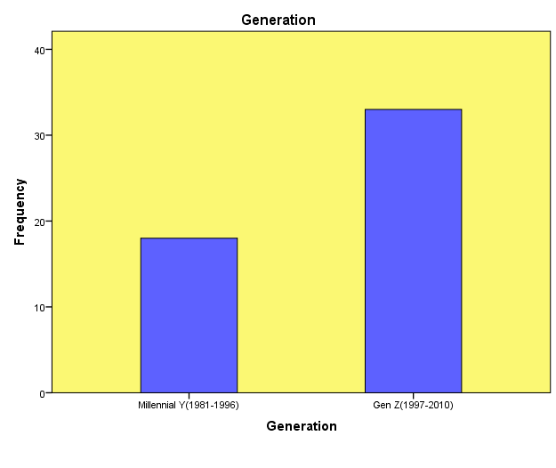*Table 3.2*

*Figure 3.1*

The majority of our study’s participants are Millennials and Gen Z, and they range in age from 20 to 40. This demonstrates unequivocally how recent developments and government initiatives have boosted youth confidence and inspired them to express their ideas without fear of failure.

**ii) Education**

|  |  |  |  |  |  |
| --- | --- | --- | --- | --- | --- |
| **Education** | | | | | |
|  | | Frequency | Percent | Valid Percent | Cumulative Percent |
| Valid | Bachelor’s degree | 15 | 29.4 | 29.4 | 29.4 |
| Master’s degree | 30 | 58.8 | 58.8 | 88.2 |
| Doctorate/Ph.D | 6 | 11.8 | 11.8 | 100.0 |
| Total | 51 | 100.0 | 100.0 |  |

*Table 3.3*

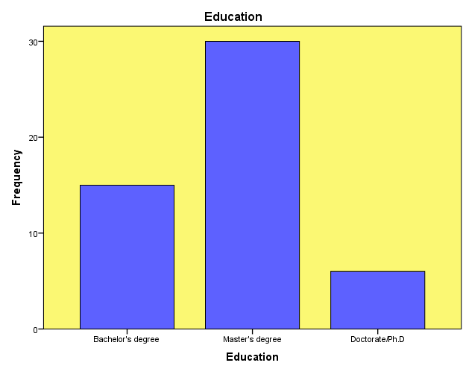

*Figure 3.2*

Most of the respondents have a Master's, Bachelor's, or Doctorate/Ph.D. degree. Notably, more than thirty of the respondents hold a Master's degree, demonstrating the critical role that postgraduate education plays in assisting students in turning their ideas into successful businesses. They can more effectively streamline their startup journey with this level of theoretical knowledge.

**iii) Startup Stage**

*Table 3.4*

|  |  |  |  |  |  |
| --- | --- | --- | --- | --- | --- |
| **Startup Stage** | | | | | |
|  | | Frequency | Percent | Valid Percent | Cumulative Percent |
| Valid | Ideation | 27 | 52.9 | 52.9 | 52.9 |
| Early Growth stage | 15 | 29.4 | 29.4 | 82.4 |
| Growth Stage | 3 | 5.9 | 5.9 | 88.2 |
| Established | 6 | 11.8 | 11.8 | 100.0 |
| Total | 51 | 100.0 | 100.0 |  |

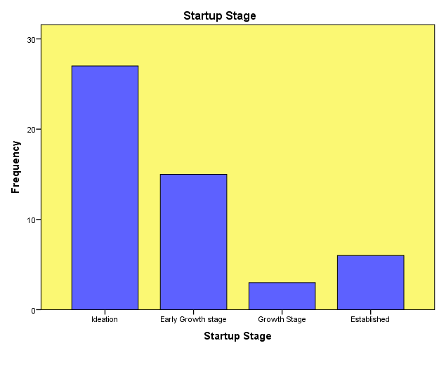

*Figure 3.3*

**iv) Type of financing startup utilized**

|  |  |  |  |  |  |
| --- | --- | --- | --- | --- | --- |
| **Which type of financing have you utilized for your startup** | | | | | |
|  | | Frequency | Percent | Valid Percent | Cumulative Percent |
| Valid | Traditional Financing | 45 | 88.2 | 88.2 | 88.2 |
| Alternative Financing | 6 | 11.8 | 11.8 | 100.0 |
| Total | 51 | 100.0 | 100.0 |  |

*Table 3.5*

The fact that the majority of respondents (52.9%) are still in the ideation stage makes it abundantly evident that most people are still developing or honing their business concepts and looking into possible avenues. This shows a forward-thinking attitude and a developing innovation culture, indicating a strong desire and intent on the part of early-stage entrepreneurs to join the startup ecosystem.

which demonstrates a high concentration of early-stage business owners developing novel concepts. Indicating active efforts to launch and scale, 29.4% are in the Early Growth stage. The majority of ventures are still in their early stages, indicating a developing but promising startup ecosystem. A smaller group is in the Growth (5.9%) and Established stages (11.8%).

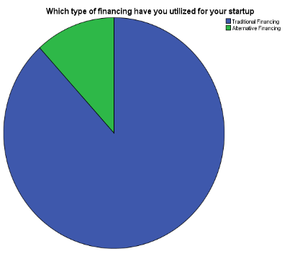

*Figure 3.4*

According to the data, a sizable majority of startups (88.2%) have opted for traditional financing, which generally consists of sources like bank loans, government grants, and bootstrapping (personal savings). This demonstrates the ongoing dependence on well-known and structured funding sources, with government assistance emerging as a significant determinant of this decision. However, only 11.8% have used alternative financing, suggesting that although these options exist, startup founders have not yet adopted them more widely.

**v) How long has your startup operates**

|  |  |  |  |  |
| --- | --- | --- | --- | --- |
| **How long has your startup been operating** | | | | |
|  | Frequency | Percent | Valid Percent | Cumulative Percent |
| less than 1 year | 24 | 47.1 | 47.1 | 47.1 |
| 1 to 2 years | 12 | 23.5 | 23.5 | 70.6 |
| 2 to 4 years | 11 | 17.6 | 17.6 | 88.2 |
| More than 5 years | 4 | 11.8 | 11.8 | 100.0 |

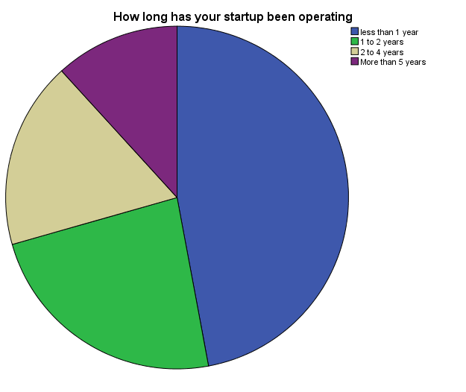*Table 3.6*

*Figure 3.5*

Nearly half of the startups (47.1%) in this survey about how long a startup has been in operation have been there for less than a year, suggesting a boom in new business endeavours. 17.6% have been in business for two to four years, while 23.5% have been in business for one to two years. While the majority of startups are still in their early phases, only 11.8% have made it past the 5-year mark, indicating that a smaller percentage have attained long-term continuity and stability.

**vi) What type of traditional financing have you used**

|  |  |  |  |  |  |
| --- | --- | --- | --- | --- | --- |
| **If you used Traditional Financing, what type did you prefer** | | | | | |
|  | | Frequency | Percent | Valid Percent | Cumulative Percent |
| Valid | Bank loans | 12 | 23.5 | 23.5 | 23.5 |
| Government Scheme | 27 | 52.9 | 52.9 | 76.5 |
| (NBFC) Loans | 6 | 11.8 | 11.8 | 88.2 |
| Not Traditional Financing | 6 | 11.8 | 11.8 | 100.0 |
| Total | 51 | 100.0 | 100.0 |  |

*Table 3.7*

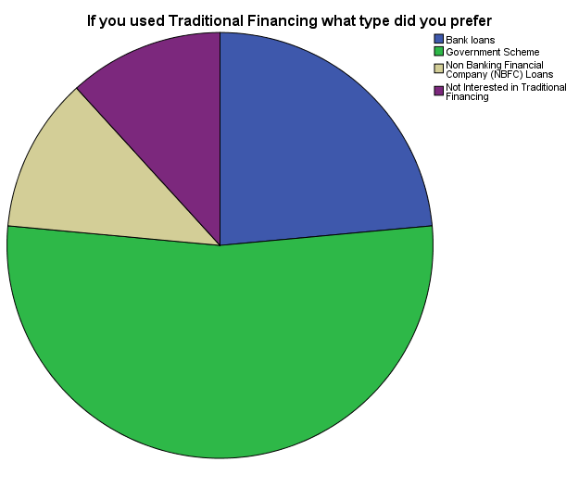

*Figure 3.6*

Expanding on the previous finding that 88.2% of startups have used traditional financing, the new data offers more detail on the particular sources that they favoured. With 52.9% of all respondents citing government schemes as their main source of funding, they stand out as the most popular choice among these. This demonstrates the increasing reliance on government-led projects, grants, and startup assistance programs, which are probably seen as more approachable, encouraging, and in line with the needs of early-stage entrepreneurs.

Private financial institutions were used sparingly but significantly, with bank loans making up 23.5% and NBFC loans 11.8%. This supports the previous finding that government programs and grants are essential for supporting startups, particularly in their early phases.

**Reliability Test**

A reliability test using Cronbach’s Alpha was performed to examine the internal consistency of the questionnaire used in this investigation. The degree of similarity between the set of items under each factor is gauged by this test. For scale reliability, a Cronbach’s Alpha value of 0.70 or higher is typically regarded as appropriate.

Factors including Awareness & Knowledge, Control over Business, Risk, Challenges, and Financial Knowledge were used in this study. Using Cronbach’s Alpha, a reliability test was performed to make sure the questions under each factor are reliable and internally consistent.

|  |  |  |
| --- | --- | --- |
| Factors | Number of Items | Cronbach’s Alpha Value |
| Awareness | 5 | .722 |
| Control over Business | 4 | .910 |
| Risk | 3 | .774 |
| Challenges | 5 | .857 |
| Financial Knowledge | 5 | .910 |

*Table 3.8*

The items under the factor Awareness are consistent and dependable, as indicated by the Cronbach's Alpha value of 0.722, which is above the acceptable threshold. With a very high Cronbach's Alpha value of 0.910, the factor Control over Business demonstrated strong response reliability and excellent internal consistency among the items. In a similar vein, the Risk factor obtained a Cronbach's Alpha value of 0.774, demonstrating that the items are successfully measuring the same concept and indicating good reliability. Strong internal consistency among the included items was confirmed by the factor Challenges, which received a value of 0.857. Finally, the Cronbach's Alpha value for the Financial Knowledge factor was 0.910, indicating exceptional consistency and dependability, similar to Control over Business.

Considering the findings, it is evident that the Cronbach's Alpha values for each of the five factors are significantly higher than the required minimum of 0.70. This attests to the statistical reliability of the study's questionnaire and the suitability of the data gathered for additional analysis, including hypothesis testing and interpretation.

The purpose of this study's reliability test was to evaluate the internal consistency of the main variables affecting startups' decisions between traditional and alternative financing. These elements awareness and knowledge, control over business, risk, challenges, and financial knowledgewere determined by a thorough literature review and primary data collection. These elements are crucial for comprehending startup financial preferences and strategic choices.

Using SPSS, the Cronbach's alpha reliability test was performed to assess the consistency within these groupings. In order to make sure that the answers are trustworthy and represent coherent constructs, this test is especially well-suited for analysing the internal consistency of grouped items within each factor. Each factor in this study had a Cronbach's alpha above the generally recognised cutoff point of 0.7, indicating a satisfactory degree of internal consistency. This implies that each factor's chosen questions measure the intended constructs in an effective manner, giving confidence in the data's dependability for additional statistical analysis.

To perform more complex statistical tests, these questions must be grouped correctly. For example, ANOVA (Analysis of Variance) assists in determining statistically significant relationships between these groups, and Independent T-tests can be used to analyse significant differences between grouping variables and specific factors. Furthermore, grouping is crucial in regression analysis to determine the proportion of influence that independent variables have on dependent variables, thereby identifying the factors that significantly affect startup funding choices. Since the goal of this study is to determine the main factors that influence startups' decisions to pursue traditional or alternative financing, this approach is especially pertinent.

It's also critical to remember that there may not be an equal distribution of questions within each factor. This illustrates the distinct intricacy and fluctuating significance of every element in the context of startup funding. A more sophisticated comprehension of the financial dynamics at work is made possible by this deliberate differentiation, which eventually strengthens the validity of the study's conclusions.

In general, reliability testing serves as a first step in guaranteeing that the analyses that follow are founded on reliable, internally consistent data, offering a strong foundation for deriving significant conclusions about startup funding choices.

**3.1.1 Chi square**

**1.** To investigate the relationship between the Source of Finance and the belief that government-backed financing options are more dependable and safer, we employed the Chi-square test in this study.

**HYPOTHESIS**

**Null Hypothesis:**

There is no significant association between the source of finance and the perception of government-backed financing options as safer and more reliable.

**Alternative Hypothesis:**

There is a significant association between the source of finance and the perception of government-backed financing options as safer and more reliable.

|  |  |  |  |  |  |  |
| --- | --- | --- | --- | --- | --- | --- |
| **Crosstab** | | | | | | |
|  | | | government-backed financing options as safer and more reliable | | | |
| Strongly Disagree | Neutral | Agree | Strongly Agree |
| Finance have startup used | Traditional Financing | Count | 0 | 12 | 18 | 15 |
| Expected Count | 5.3 | 10.6 | 15.9 | 13.2 |
| Alternative Financing | Count | 6 | 0 | 0 | 0 |
| Expected Count | .7 | 1.4 | 2.1 | 1.8 |

|  |  |  |  |
| --- | --- | --- | --- |
| **Chi-Square Tests** | | | |
|  | Value | df | Asymp. Sig. (2-sided) |
| Pearson Chi-Square | 51.000a | 3 | .000 |
| Likelihood Ratio | 36.945 | 3 | .000 |
| Linear-by-Linear Association | 32.504 | 1 | .000 |

*Table 3.9*

**Interpretation -** We reject the null hypothesis because the p-value is less than 0.05, which shows a statistically significant relationship between Source of Finance and the belief that government-backed financing is more trustworthy and safer. Significant results with p-values of 0.000 are also shown by the Likelihood Ratio (36.945) and Linear-by-Linear Association (32.504), confirming that the relationship is unlikely to be the result of chance.   
This implies that the choice of funding source is greatly influenced by the availability of government-backed assistance. If respondents believe government-backed financing is safer and more dependable, they might favour traditional or alternative financing.

**2. HYPOTHESIS**

**Null Hypothesis:**

There is no significant association between the source of finance and the concern that equity dilution while choosing alternative financing.

**Alternative Hypothesis:**

There is a significant association association between the source of finance and the concern that equity dilution while choosing alternative financing.

|  |  |  |  |
| --- | --- | --- | --- |
| **Chi-Square Tests** | | | |
|  | Value | df | Asymp. Sig. (2-sided) |
| Pearson Chi-Square | 12.467a | 2 | .002 |
| Likelihood Ratio | 14.031 | 2 | .001 |
| Linear-by-Linear Association | 9.818 | 1 | .002 |

*Table 3.10*

**Interpretation:**

There is a statistically significant correlation between the Source of Finance and the worry about equity dilution in alternative financing, as indicated by the p-value < 0.05, which leads us to reject the null hypothesis.

This suggests that respondents' concerns regarding equity dilution when contemplating alternative funding options vary considerably depending on whether they prefer traditional, alternative, or both forms of financing. Put differently, equity dilution has a big impact on the kind of funding source that is selected.

**3.1.2 ANOVA**

Our study uses analysis of variances (ANOVA) to examine the differences between independent and dependent variables. In this case, the independent variable is the startup year, and the dependent variable is the degree of startup awareness and the difficulties faced by startups.

|  |  |  |  |  |  |  |
| --- | --- | --- | --- | --- | --- | --- |
| **ANOVA** | | | | | | |
|  | | Sum of Squares | df | Mean Square | F | Sig. |
| Awareness_score | Between Groups | 121.688 | 3 | 40.563 | 5.366 | .003 |
| Within Groups | 332.625 | 44 | 7.560 |  |  |
| challenges_score | Between Groups | 490.787 | 3 | 163.596 | 33.340 | .000 |
| Within Groups | 230.625 | 47 | 4.907 |  |  |

*Table 3.11*

|  |  |  |  |  |  |  |
| --- | --- | --- | --- | --- | --- | --- |
| **POST HOC** | | | | | | |
| Games-Howell | | | | | | |
| Dependent Variable | | | Mean Difference (I-J) | Sig. | 95% Confidence Interval | |
| Lower Bound | Upper Bound |
| Awareness | less than 1 year | 1 to 2 | 2.87500 | .287 | -1.6835 | 7.4335 |
| 2 to 4 | 3.87500* | .000 | 3.2022 | 4.5478 |
| More than 5 | -.12500 | .955 | -.7978 | .5478 |
| 1 to 2 years | less than 1 | -2.87500 | .287 | -7.4335 | 1.6835 |
| 2 to 4 | 1.00000 | .909 | -3.5371 | 5.5371 |
| More than 5 | -3.00000 | .249 | -7.5371 | 1.5371 |
| 2 to 4 years | less than 1 | -3.87500* | .000 | -4.5478 | -3.2022 |
| 1 to 2 | -1.00000 | .909 | -5.5371 | 3.5371 |
| More than 5 | -4.00000 |  | -4.0000 | -4.0000 |
| More than 5 years | less than 1 | .12500 | .955 | -.5478 | .7978 |
| 1 to 2 | 3.00000 | .249 | -1.5371 | 7.5371 |
| 2 to 4 | 4.00000 |  | 4.0000 | 4.0000 |

|  |  |  |  |  |  |  |
| --- | --- | --- | --- | --- | --- | --- |
| challenges | less than 1 year | 1 to 2 | 6.12500* | .000 | 3.3400 | 8.9100 |
| 2 to 4 | 7.12500* | .000 | 3.8982 | 10.3518 |
| More than 5 | 2.12500* | .000 | 1.2869 | 2.9631 |
| 1 to 2 years | less than 1 | -6.12500* | .000 | -8.9100 | -3.3400 |
| 2 to 4 | 1.00000 | .879 | -2.8154 | 4.8154 |
| More than 5 | -4.00000* | .005 | -6.7222 | -1.2778 |
| 2 to 4 years | less than 1 | -7.12500* | .000 | -10.3518 | -3.8982 |
| 1 to 2 | -1.00000 | .879 | -4.8154 | 2.8154 |
| More than 5 | -5.00000* | .005 | -8.2024 | -1.7976 |
| More than 5 years | less than 1 | -2.12500* | .000 | -2.9631 | -1.2869 |
| 1 to 2 | 4.00000* | .005 | 1.2778 | 6.7222 |
| 2 to 4 | 5.00000* | .005 | 1.7976 | 8.2024 |

*Table 3.12*

**Interpretation:**

Based on the startup year, there is a statistically significant difference between the groups in the Awareness Score (p = 0.003 < 0.05). This implies that the awareness level of startups is influenced by the startup year.

The awareness scores of startups that have been in business for two to four years and those that have been in business for less than a year differ statistically significantly, according to the Games-Howell test. With a p-value of 0.000 and a mean difference of 3.875, the 2–4 year startups have significantly higher awareness. Since their p-values are above 0.05, no significant difference was observed between other groups, such as 1–2 years vs. <1 year.  
Additionally, the Challenges Score reveals a highly significant difference between groups according to the year of startup (p = 0.000 < 0.05). This suggests that the difficulties faced by startups are greatly influenced by the startup year.

Startups that have been in business for less than a year face substantially more difficulties than those that have been in business for more than five years, according to the post hoc analysis using the Games-Howell test (mean difference = 2.125, p =.000).

This makes it abundantly evident that, in contrast to more established startups, newer ones are facing greater difficulties.

**2. Factor:** Startup stage

**Dependent List:** Risk_factor

**HYPOTHESIS:**

**Null Hypothesis:**

There is **no significant difference** in the perceived risk score across different startup stages.

**Alternative Hypothesis:**

There is a significant difference in the perceived risk score across different startup stages.

|  |  |  |  |  |  |
| --- | --- | --- | --- | --- | --- |
| **ANOVA** | | | | | |
|  | Sum of Squares | df | Mean Square | F | Sig. |
| Between Groups | 91.286 | 3 | 30.429 | 3.676 | .018 |
| Within Groups | 389.067 | 47 | 8.278 |  |  |

|  |  |  |  |  |  |  |
| --- | --- | --- | --- | --- | --- | --- |
| **POST HOC** | | | | | | |
| (I) Startup Stage | | Mean Difference (I-J) | Std. Error | Sig. | 95% Confidence Interval | |
| Lower Bound | Upper Bound |
| Ideation | Early Growth stage | .31111 | 1.15029 | .993 | -2.9098 | 3.5320 |
| Growth Stage | -.88889 | .47542 | .265 | -2.1931 | .4153 |
| Established | 4.11111* | .47542 | .000 | 2.8069 | 5.4153 |
| Early Growth stage | Ideation | -.31111 | 1.15029 | .993 | -3.5320 | 2.9098 |
| Growth Stage | -1.20000 | 1.04745 | .669 | -4.2445 | 1.8445 |
| Established | 3.80000* | 1.04745 | .013 | .7555 | 6.8445 |
| Growth Stage | Ideation | .88889 | .47542 | .265 | -.4153 | 2.1931 |
| Early Growth stage | 1.20000 | 1.04745 | .669 | -1.8445 | 4.2445 |
| Established | 5.00000 | 0.00000 |  | 5.0000 | 5.0000 |
| Established | Ideation | -4.11111* | .47542 | .000 | -5.4153 | -2.8069 |
| Early Growth stage | -3.80000* | 1.04745 | .013 | -6.8445 | -.7555 |
| Growth Stage | -5.00000 | 0.00000 |  | -5.0000 | -5.0000 |

*Table 3.13*

**Interpretation:**

Risk perception changes as startups move through different stages, according to the analysis, which shows a significant difference in perceived risk across startup stages (F = 3.676, p = 0.018). This discrepancy is further explained by the post-hoc test, which reveals that established startups have substantially lower risk scores than ideation, early growth, and growth stage.  
According to the results, startups in the Ideation and Early Growth stages perceive greater risk, most likely as a result of their inexperience in the market, hazy revenue streams, and unproven business models. Since these early-stage startups are still determining their financial stability and product-market fit, there is inevitably more risk and uncertainty involved.

However, compared to startups in their early stages, established startups report the lowest risk perception (p < 0.05). Their improved financial support, operational stability, and stronger market position may be the reasons for this. Startups’ perceived risk decreases as they get more seasoned at managing external uncertainties, optimising business strategies, and navigating financial risks.

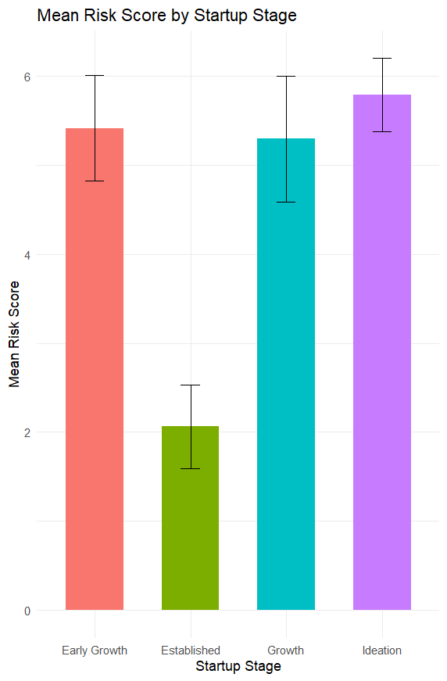

**3.1.3 Independent T-test**

*Figure 3.7*

**i) Grouping variable – Education (UG/PG)**

### **Target Variable – Risk_score (Risks faced by startups)**

**HYPOTHESIS**

**Null Hypothesis (H0):**

There is no significant difference in risk perception between respondent with undergraduate and postgraduate education levels

**Alternative Hypothesis (H1):**

There is a significant difference in risk perception between respondents with undergraduate and postgraduate education levels

|  |  |  |  |  |  |  |  |  |  |  |
| --- | --- | --- | --- | --- | --- | --- | --- | --- | --- | --- |
| **Independent Samples Test** | | | | | | | | | | |
|  | | Levene’s Test | | t-test for Equality of Means | | | | | | |
| F | Sig. | t | df | Sig. (2-tailed) | Mean Difference | Std. Error Difference | 95% Confidence Interval of the Difference | |
| Lower | Upper |
| risk | variances assumed | .210 | .649 | -2.458 | 43 | .018 | -2.20000 | .89495 | -4.00483 | -.39517 |
| variances not assumed |  |  | -2.734 | 37.123 | .010 | -2.20000 | .80454 | -3.82998 | -.57002 |

*Table 3.14*

**Interpretation**

The risk perception scores of undergraduate (UG) and graduate (PG) students were compared using an independent samples t-test. The assumption of equal variances was satisfied, according to the results of Levene’s test (F = 0.210, p = 0.649). As a result, the t-test was predicated on equal variances. UG and PG students’ perceptions of risk differed statistically significantly, according to the analysis (t(43) = -2.458, p = 0.018). PG students had lower risk perception scores than UG students, as indicated by the mean difference of -2.20. This notable distinction might result from postgraduate students’ greater experience and self-assurance, which enable them to act more freely and audaciously when implementing their ideas.

ii) Grouping variable – Type of Financing for startups

Target Variable – Awareness_score (Awareness about source of financing for startups)

**HYPOTHESIS**

**Null Hypothesis**

There is no statistically significant difference in the mean awareness levels between startups using **traditional financing** and those using **alternative financing.**

**Alternative Hypothesis**

There is a statistically significant difference in the mean awareness levels between startups using **traditional financing** and those using **alternative financing.**

|  |  |  |  |  |  |  |  |  |  |  |
| --- | --- | --- | --- | --- | --- | --- | --- | --- | --- | --- |
| **Independent Samples Test** | | | | | | | | | | |
|  | | Levene’s Test | | t-test for Equality of Means | | | | | | |
| F | Sig. | t | df | Sig. (2-tailed) | Mean Difference | Std. Error Difference | 95% Confidence Interval | |
| Lower | Upper |
| Aware | variances assumed | 7.366 | .009 | 2.372 | 46 | .022 | 3.07143 | 1.29465 | .46542 | 5.67743 |
| variances not assumed |  |  | 6.335 | 41.000 | .000 | 3.07143 | .48484 | 2.09228 | 4.05058 |

*Table 3.15*

**Interpretation:**

To find out if there is a significant difference in awareness between startups using traditional financing and those using alternative financing, an Independent Samples t-test was used. The assumption of equal variances was examined using Levene’s Test for Equality of Variances. The assumption of equal variances was broken, as evidenced by the significant Levene’s Test result (F = 7.366, p = 0.009). For interpretation, we thus consult the row labelled “Equal variances not assumed.” With t(41.000) = 6.335, p = 0.000, the t-test indicated a statistically significant difference in awareness between the two financing types. With a 95% CI between 2.09228 and 4.05058, the mean difference was 3.07143. This positive mean difference shows that traditional financing startups are much more aware than those using alternative financing.

We conclude by rejecting the null hypothesis and acknowledging that the two groups’ levels of awareness differ significantly, with Traditional Financing being linked to higher levels of awareness.

**3.1.4 Correlation**

|  |  |  |  |  |  |
| --- | --- | --- | --- | --- | --- |
| **Correlations** | | | | | |
|  | | Awareness_score | flexibility_score | risk_score | challenges_score |
| Awareness_score | Pearson Correlation | 1 | .657** | .753** | .765** |
| Sig. (2-tailed) |  | .000 | .000 | .000 |
| flexibility_score | Pearson Correlation | .657** | 1 | .507** | .455** |
| Sig. (2-tailed) | .000 |  | .000 | .001 |
| risk_score | Pearson Correlation | .753** | .507** | 1 | .776** |
| Sig. (2-tailed) | .000 | .000 |  | .000 |
| challenges_score | Pearson Correlation | .765** | .455** | .776** | 1 |
| Sig. (2-tailed) | .000 | .001 | .000 |  |

*Table 3.16*

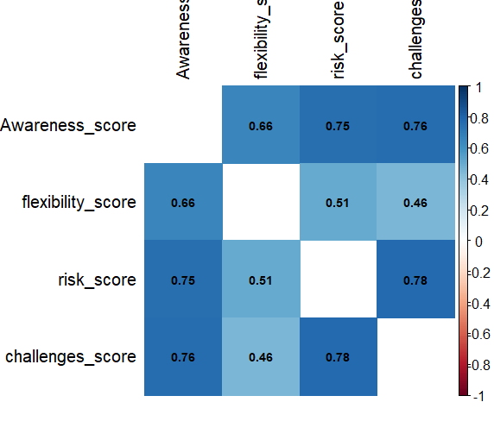

*Figure 3.8*

**Interpretation:**

The four main factors Awareness Score, Flexibility Score, Risk Score, and Challenges Score were compared using the Pearson correlation analysis. The correlation matrix above displays the results, and the following explains the main relationships:

* The Awareness Score and Risk Score (r = 0.753, p < 0.01) and the Awareness Score and Challenges Score (r = 0.765, p < 0.01) have a strong positive correlation. This suggests that respondents tend to perceive greater risk and recognise more challenges as their level of awareness rises. It demonstrates that people with greater awareness are also more cognisant of the risks and difficulties associated with making financial decisions.
* Additionally, there is a moderate to strong positive correlation between the Flexibility Score and the Awareness Score (r = 0.657, p < 0.01), indicating that people who are more aware are probably more in control of their financing options.
* The Flexibility Score has a moderate correlation with the Risk Score (r = 0.507, p < 0.01) and the Challenges Score (r = 0.455, p < 0.01). This suggests that people who have flexible financing options also typically recognise the risks and difficulties that come with them. Despite their weakness, the relationships are statistically significant and important for comprehending respondents' perceptions.
* The Risk Score and Challenges Score have the strongest correlation (r = 0.776, p < 0.01). This demonstrates that respondents who are more risk-aware are also more likely to comprehend the difficulties. In the processes of planning and decision-making, these two elements are intimately connected.

According to the correlation analysis, there is a positive relationship between all four factors, with significant relationships at the 0.01 level. This suggests that raising awareness can result in a deeper comprehension of the challenges, risks, and flexibility associated with financial decisions. The results validate the study's overarching hypothesis, which holds that these factors are interrelated and collectively influence how people or companies behave in the financial ecosystem.

**3.1.5 Regression**

**HYPOTHESIS**

**Null Hypothesis:**

There is no significant influence of Awareness Score and Financial Score on the likelihood of securing traditional financing for start-ups.

**Alternative Hypothesis (H₁):**

There is a significant influence of Awareness Score and Financial Score on the likelihood of securing traditional financing for start-ups.

|  |  |  |  |  |
| --- | --- | --- | --- | --- |
| **Model Summary** | | | | |
| Model | R | R Square | Adjusted R Square | Std. Error of the Estimate |
| 1 | .550a | .302 | .271 | .747 |

|  |  |  |  |  |  |  |
| --- | --- | --- | --- | --- | --- | --- |
| **ANOVA** | | | | | | |
| Model | | Sum of Squares | df | Mean Square | F | Sig. |
| 1 | Regression | 10.883 | 2 | 5.441 | 9.749 | .000b |
| Residual | 25.117 | 45 | .558 |  |  |
| Total | 36.000 | 47 |  |  |  |

*Table 3.17*

**Interpretation**

The dependent variable (Start-ups with strong fundamentals are more likely to secure traditional financing easily) and the independent variables (Awareness Score and Financial Score) have a moderately positive relationship, as indicated by the Model Summary's R value of 0.550. The independent variables in the model can account for roughly 30.2% of the variation in the dependent variable, according to the R-squared value of 0.302. The model still explains a sizable portion of the variation, according to the Adjusted R-squared value of 0.271, even after accounting for the number of predictors.

With a p-value of 0.000 and an F-value of 9.749, the ANOVA results are statistically significant. This indicates that start-ups with solid financial foundations have a higher chance of obtaining traditional financing, a prediction that is greatly influenced by the independent variables (Awareness Score and Financial Score). In other words, the possibility of obtaining funding from conventional sources is increased by possessing a solid grasp of finance.

**CHAPTER 4**

**SUMMARY & SUGGESTION**

**Chapter – 4**

**Summary & Suggestions**

**4.1 Summary of Findings**

The purpose of this study was to look into the main variables that affect start-ups' capacity to obtain conventional funding. The association between independent variables like financial knowledge, awareness, and start-up characteristics and the possibility of obtaining financing was evaluated using a variety of statistical analyses, such as Chi-Square, Independent t-test, ANOVA, Correlation, and Regression Analysis. A thorough synopsis of the conclusions drawn from these analyses is provided below:

1. Chi-Square   
   The results of the Chi-Square test showed a significant correlation between the perceived safety and dependability of government-backed financing options and the source of funding. Government-backed funding is more likely to be seen as a safer and more dependable option by startups that take it into consideration. Furthermore, the findings showed that start-ups choosing alternative financing still have serious concerns about equity dilution. The trade-off between risk and control in financing decisions is highlighted by the fact that startups frequently favour financing options with the least amount of equity dilution.
2. The groups differed significantly on a number of factors, according to the independent t-test. For instance, the group of start-ups with better access to traditional financing had significantly higher financial knowledge (as indicated by awareness scores) than the group with less access. This implies that traditional funding is more likely to be obtained by start-ups with greater financial expertise. Additionally, the test demonstrated that start-ups at various phases of their operations (new vs. mature start-ups, for example) have unique financial challenges and characteristics that impact their financing choices.
3. The ANOVA analysis revealed notable variations in awareness scores and difficulties encountered among start-ups at different phases of their lifecycle. It was discovered that startups that have been in business for less than a year encounter a lot more difficulties than those that have been in business for more than five years. Additionally, compared to more established companies, newer start-ups had lower awareness scores, which reflected the difficulties they have comprehending the financial landscape. According to the post-hoc analysis, start-ups in their first year of operation faced significantly different challenges than those in the five-year or longer category.
4. Strong positive correlations between important financial factors were found by the correlation analysis. Flexibility and risk management scores were positively connected with awareness scores, suggesting that more informed start-ups are better able to manage financial risks and show more flexibility when it comes to financing choices. Additionally, there was a strong positive correlation between the challenges score and financial knowledge and awareness, indicating that more knowledge aids start-ups in managing their financial difficulties.
5. The impact of the Financial Score and Awareness Score on the possibility of obtaining conventional financing was investigated using regression analysis. The dependent variable and these factors had a moderate relationship, according to the results. The independent variables (Awareness Score and Financial Score) can account for 30.2% of the variation in the likelihood of obtaining traditional financing, according to the Model Summary's R-square value of 0.302. The likelihood of obtaining traditional financing is significantly influenced by financial knowledge and awareness, as confirmed by the significant ANOVA for this model (F-value = 9.749, p-value = 0.000).
6. To sum up, the results clearly imply that start-ups with greater financial awareness and expertise are more likely to be able to obtain conventional funding. According to the analysis, a start-up's chances of obtaining traditional funding increase with their level of understanding of financial concepts and risks. The study also showed that newer start-ups typically have a harder time getting funding, but that as they get more experience and financial literacy, they get better at overcoming these obstacles.

In addition to having a higher chance of obtaining conventional funding, startups with stronger financial foundations—such as greater awareness and financial literacy—are also better able to make wise choices about risk, long-term growth, and equity dilution. Since newer start-ups frequently face more obstacles in the early stages of their operations, these findings underscore the significance of financial education and the need for customised support.

There is a discernible trend in India's startup scene right now: a large number of founders are undergraduate or graduate students. These young brains are not only generating ideas but also fearlessly carrying out their startup plans, frequently supported by the theoretical knowledge they have acquired throughout their academic careers. They are better able to understand financial concepts, risks, and strategic choices as a result of their academic exposure, which increases their confidence when navigating the different funding options.

Compared to those in advanced stages, the majority of these early-stage startups appear to face more difficulties, especially those that have been in operation for less than a year. However, these difficulties begin to lessen with time and experience, and their awareness and strategic management increase. As they advance, the awareness of financing options, risk management, and flexibility increases.

It's interesting to note that founders' perceptions and choices regarding their source of funding are influenced by the startup stage. For instance, those who are just starting out frequently depend more on safer, government-supported options. This decision involves not only capital but also the security and dependability that these sources offer, particularly in situations where there is a significant concern about equity dilution.

There is a change among generations as well. Although they do so cautiously—only if they believe it won't affect their control or ability to make decisions—the younger generation appears more receptive to investigating alternative financing. On the other hand, more seasoned business owners—typically older or having been in the industry for a longer period of time—prefer conventional financing and possess a greater comprehension of risk management and financial planning.

All things considered, financial awareness and expertise stand out as important facilitators. Their capacity to assess funding opportunities and make sound foundational decisions improves with increasing knowledge. Additionally, given the changing environment, startups that establish this financial strength early on appear to have an easier time achieving stability and expansion.

**4.2 Suggestions / Recommendation**

It is evident from the study and observations that Indian startups are still developing their financial decision-making skills. Undergraduates and graduate students who have big ideas but require more financial clarification are starting a lot of them. Therefore, it is highly recommended that more awareness sessions and workshops be held, with a particular emphasis on financial literacy, funding sources, and a fundamental understanding of risk and flexibility. Startups will be more confident when making funding decisions if they receive the proper exposure in the early stages.

Additionally, compared to more established startups, startups in their early stages encounter more difficulties. More early-stage support systems, such as incubation, mentoring, and access to government programs, should therefore be made available. They can concentrate on growth instead of just sustainability thanks to these, which lessen the initial struggle.

Another finding was that, if available, startups typically favour government-backed funding because they perceive it as safer and more dependable. This suggests that government programs should be made more accessible and easier to use; additionally, it is crucial to properly promote them, as many startups are unaware that they are available.

Another significant issue with alternative financing is equity dilution. Therefore, it's critical that founders understand how to strike a balance between control and funding. They may overlook excellent funding opportunities out of ignorance or a fear of losing ownership. Simple tutorials or sessions that cover these subjects in a way that is appropriate for new businesses should be available.

From the standpoint of generation, it was also noted that younger founders require guidance even though they are more willing to try new things. On the other hand, seasoned founders are more stable but also more cautious. Therefore, it would be advised to develop mentoring models based on age or experience, where the founder's stage and background are taken into account when providing support.

Finally, we found that risk-taking ability, flexibility, financial awareness, and knowledge are all related. Therefore, a multifaceted strategy is required, not only to teach numbers but also to insists some confidence in founders to make financial decisions based on reason and vision.

**4.3 Limitations**

This study has several limitations that should be noted, despite its efforts to address various facets of startup funding and founder perception. First and foremost, the results might not accurately reflect the whole startup population in India due to the small sample size. We might have observed more variances and trends if there had been a larger sample size.

One important thing to keep in mind is that the majority of the responses came from startups that were supported by the Crescent Innovation & Incubation Council, or CIIC. These startups are typically exposed to formal financing methods and receive structured guidance. As a result, the results may be slightly biassed in favour of conventional financing options because their choices may be impacted by formal mentorship and incubator frameworks, as opposed to independent or bootstrapped businesses that might take a completely different tack.

Additionally, we have focused the study variables on topics like financial awareness, knowledge, flexibility, risk attitude, and challenges. However, the scope of this project did not allow us to include many of the more important elements found in the real ecosystem, such as team competence, investor dynamics, market trends, regulatory ease, tech adoption, and mentorship.

We were also unable to record changing viewpoints due to the study's time frame. Decisions made by founders are subject to change in response to funding trends, market conditions, and even modifications in policy. Therefore, a longitudinal approach could provide more real-time insights, which was not possible at this point.

The responses were skewed towards younger founders (primarily from undergraduate and postgraduate backgrounds) and primarily came from a specific region in terms of geography and demographics. Therefore, the results might not accurately represent the ideas and tactics of the founders who were older, more seasoned, or from a rural area.

The fact that we only looked at active startups presented another difficulty. This lacks the experience and lessons learnt from startups that have failed or been paused, which could offer insightful alternative perspectives.

Last but not least, the study mostly relied on Likert scale responses, which are useful for measuring perceptions but limit in-depth thoughts or firsthand knowledge. We could have provided more insightful context for the numbers if we had included interviews or open-ended responses.

**4.4 Direction for Future Research**

The current study looked at how awareness, adaptability, risk, and difficulties relate to both conventional and alternative funding sources. To comprehend the nature of association, group-wise differences, and the influence of predictor variables on outcomes, a variety of statistical techniques were used, including linear regression, independent samples t-test, and correlation analysis. Even though the findings have yielded important new information, some topics remain unexplored. The present analysis suggests the following lines of inquiry for further study:

1. Employing sophisticated multivariate methods :  
   Future research can investigate multiple regression, logistic regression, or structural equation modelling (SEM) to examine the combined and indirect effects among multiple variables, particularly when working with larger datasets, even though linear regression was used in this study to identify predictive relationships.
2. Expansion of Sample Size and Scope   
   This study's conclusions are predicated on a particular sample group. Future research could concentrate on a larger and more varied population, encompassing various regions, company sizes, and sector types, which would improve the validity and relevance of the results.
3. Adding More Influential Elements

The study primarily focused on four key dimensions. Future researchers can incorporate variables like:

* + Financial literacy
  + Access to funding networks
  + Use of technology in financial decisions
  + Entrepreneurial motivation or experience  
    These could provide a broader understanding of what drives financing preferences and awareness levels.

1. Including Qualitative Approaches   
   Future research could use a mixed-methods approach by incorporating interviews or open-ended responses, as the current study was fully quantitative. This would assist in obtaining more profound understandings of the numerical patterns seen.
2. Time-series or longitudinal analysis   
   A longitudinal study design can be used to comprehend changes over time. This would show how financing preferences, risk perception, and awareness change over time, particularly when new funding options or regulations are implemented.
3. Comparative Studies Based on Sectors   
   Future studies can compare industries like manufacturing, services, or tech startups to see if the variables affecting financial choices vary depending on the difficulties faced by each sector.
4. Aspects of Behaviour and Psychology   
   Beyond flexibility or numerical awareness, behavioural factors like risk tolerance, confidence in financial decisions, or trust in financial institutions would provide a different perspective on the decision-making process.
5. Impact on Institutions and Policy   
   Lastly, examining how financial institutions, government programs, and regulations shape financial literacy and accessibility may help future research better reflect practical solutions.

**Conclusion:**

This project aimed to provide data-driven insights into the comparative dynamics of traditional financing and alternative financing for the startup ecosystem, focusing on key factors like awareness, knowledge, flexibility, control over business, risk, stability, and associated challenges. The analysis was conducted using statistical methods such as Chi-square and ANOVA, revealing critical patterns that offer valuable insights for entrepreneurs, investors, and policymakers. The study found that awareness and understanding of various funding options significantly influence the financing choices of startups. Entrepreneurs with higher awareness tend to explore a broader range of funding alternatives, reducing their dependency on traditional financing. Additionally, alternative financing models, including venture capital, angel investments, and peer-to-peer lending, often provide greater flexibility and allow founders more control over their businesses. In contrast, traditional funding methods, like bank loans, typically come with more rigid repayment structures and stringent collateral requirements. Traditional financing generally offers more stability but can limit growth opportunities due to conservative lending practices, while alternative financing can be riskier but provides higher growth potential and scalability. However, the analysis also highlighted that startups face significant challenges when opting for alternative financing, including investor expectations, equity dilution, and regulatory complexities. These factors must be carefully considered before choosing a funding route.

The findings suggest that a balanced approach, leveraging both traditional and alternative financing options, can offer startups the flexibility needed to scale while maintaining financial stability. Policymakers can use these insights to design supportive frameworks that encourage innovation while mitigating risks. Financial institutions and investors can also develop more tailored funding products to meet the evolving needs of startups.

Further research can explore the long-term impacts of different financing strategies on startup success rates, sector-specific funding challenges, and the role of digital financial platforms in bridging funding gaps. Additionally, deeper analysis using primary data and more advanced statistical techniques could provide a more comprehensive understanding of this evolving landscape. In conclusion, this project has provided a detailed comparative analysis, offering valuable insights into the financial decision-making processes within the startup ecosystem. By integrating these findings into strategic planning, startups can make more informed choices, enhancing their growth potential and long-term sustainability.

**CHAPTER 5**

**ANNEXURE**

**ANNEXURE**

**QUESTIONNAIRES**

**1. Gender**

* Male
* Female

**2. Generation**

* Millennial Y (1981-1996)
* Gen Z (1997-2010)

**3. Education**

* High school
* Bachelor's degree
* Master's degree
* Doctorate/Ph.D

**4. Startup Stage**

* Ideation
* Early Growth Stage
* Growth Stage
* Scaling
* Established

**5. Type of Financing**

* Traditional Financing
* Alternative Financing

**6. Which Industry does your Startup operates**

* Industry 4.0
* Life science
* Smart&clean Mobility
* Defence

**7. How long has your startup been operating**

* Less than 1 year
* 1 to 2 years
* 2 to 4 years
* More than 5 years

**8. If you traditional Financing what type did you prefer**

* Bank loans
* Government scheme
* Non-banking Financial Company
* Development Financing Institutions
* Not Interested in Traditional Financing

**9. If you used alternative Financing, what type did you prefer**

* Angel Investors
* Venture Capital
* Bootstrapping
* Revenue Based financing
* Not Interested in alternative Finance

**10. Startups with strong fundamentals are, more likely to secure traditional financing easily**

* Strongly Disagree
* Disagree
* Neutral
* Agree
* Strongly Agree

**Awareness of Financing options**

**11.** My startup is well-informed about the differences between traditional and alternative financing methods.

**12.** We understand the eligibility criteria required to access bank loans and government-backed financing schemes.

**13.** My startup consults financial experts or advisors before making funding decisions.

**14**. We understand that government schemes like Startup India, SIDBI, and MSME loans provide financial support to eligible startups.

**15.** My startup is aware of sector-specific funding opportunities, such as biotech grants, manufacturing subsidies, and fintech accelerator programs.

**Control over Business Factor**

**16.** My startup prefers financing options that provide flexibility in repayment terms.

17. Receiving funds in stages (milestone-based) under traditional financing motivates our team to complete projects faster.

18. Maintaining control over decision-making is a priority when choosing a financing method.

19. Equity dilution is a major concern when considering alternative financing options like venture capital or angel investment.

20. Alternative financing options provide greater flexibility in fund utilization compared to traditional financing.

**Risk & Stability Factor**

**17.** We prefer traditional financing due to its structured and regulated nature, which ensures financial security

18. My startup considers government-backed financing options as safer and more reliable.

23. My startup has contingency plans in place to manage financial instability

24. Alternative Financing provide not just funding but also mentorship and business expertise.

25. OCD/CCD funding has improved our start-up’s financial stability during early growth stages

**Challenges Factor**

**26.** The documentation required for traditional financing is excessively burdensome.

27. Stringent eligibility criteria make it difficult for early-stage start-ups to secure traditional financing.

28. A lack of business credit history prevents startups from getting loans from banks and NBFCs.

29. Startups without strong networks find it challenging to connect with investors.

30. The valuation process in alternative financing is subjective and often investor-driven.

**Bibliography**

***Crescent Innovation and Incubation Council***

[**https://ciic.ventures/**](https://ciic.ventures/)

***Sources of finance for tech startups over its lifecycle:(2021)***

[*https://www.emerald.com/insight/content/doi/10.1108/ijoem-06-2020-0705/full/html*](https://www.emerald.com/insight/content/doi/10.1108/ijoem-06-2020-0705/full/html)

**An empirical study on startup financing for entrepreneurs in india(2022)**

[*https://link.springer.com/article/10.1007/s10690-023-09434-7*](https://link.springer.com/article/10.1007/s10690-023-09434-7)

**A Critical Study of Startup Financing Dynamics and Emerging Approach to Attracting Capital Resources(2022)**

[*https://scholar.google.com/scholar?hl=en&as_sdt=0%2C5&q=A+Critical+Study+of+Startup+Financing+Dynamics+and+Emerging+Approach+to+Attracting+Capital+Resources%282022%29&btnG=*](https://scholar.google.com/scholar?hl=en&as_sdt=0%2C5&q=A+Critical+Study+of+Startup+Financing+Dynamics+and+Emerging+Approach+to+Attracting+Capital+Resources%282022%29&btnG=)

**A study of Financing Sources for Start-up Companies in India**

[*https://scholar.google.com/scholar?hl=en&as_sdt=0%2C5&q=A+study+of+Financing+Sources+for+Start-up+Companies+in+India&btnG=*](https://scholar.google.com/scholar?hl=en&as_sdt=0%2C5&q=A+study+of+Financing+Sources+for+Start-up+Companies+in+India&btnG=)

**A Study on Fintech Start-Ups in India with Special Reference to Payments**

[*https://www.inderscienceonline.com/doi/pdf/10.1504/IJBIR.2022.121542*](https://www.inderscienceonline.com/doi/pdf/10.1504/IJBIR.2022.121542)

**Startup Financing: Some Evidence from the Indian Venture Capital Industry (2019)**

[*https://journals.sagepub.com/doi/abs/10.1177/23197145221142109*](https://journals.sagepub.com/doi/abs/10.1177/23197145221142109)

**A Study on Bootstrapping Financing Methods Employed in Indian Small and Medium Scale Enterprises**

[*https://shorturl.at/SoL7l*](https://shorturl.at/SoL7l)

**Predicting Startup Valuation Using Deep Learning: A Data-Driven Analysis**

[*https://shorturl.at/kjTkF*](https://shorturl.at/kjTkF)

**The Impact of Initial Funding Amounts on Business Success Rates by Venture Capitalist**

[*https://www.sciencedirect.com/science/article/pii/S0304405X20300337*](https://www.sciencedirect.com/science/article/pii/S0304405X20300337)

**Startup TN**

[*https://startuptn.in/*](https://startuptn.in/)

**Startup India**

[*https://www.startupindia.gov.in/content/sih/en/international/go-to-market-guide/indian-startup-ecosystem.html*](https://www.startupindia.gov.in/content/sih/en/international/go-to-market-guide/indian-startup-ecosystem.html)

230292601074_VER1_Eniyavan.

ORIGINALITY REPORT

7% 6% 5% 3%

SIMILARITY INDEX INTERNET SOURCES PUBLICATIONS STUDENT PAPERS

|  |  |
| --- | --- |
| PRIMARY SOURCES |  |
| 1 www.ciic.venturesInternet Source | 1% |
| 2 mail.mjltm.orgInternet Source | <1% |
| 3 Hafinaz, R Hariharan, R. Senthil Kumar. "Recent Research in Management, Accounting and Economics (RRMAE) - A case study on Recent Research in Management, Accounting and Economics", Routledge, 2025  Publication | <1% |
| 4 Submitted to Canadian International School, Singapore  Student Paper | <1% |
| 5 repository.radenintan.ac.idInternet Source | <1% |
| 6 clutejournals.comInternet Source | <1% |
| 7 repository.um.edu.myInternet Source | <1% |